DEPARTMENT OF COMPUTER ENGINEERING
CLOUD COMPUTING & FRAMEWORKS
EXPERIMENT NO. 07
STUDY AND IMPLEMENTATION OF DATABASE AS A SERVICE (DBAAS) CLOUD SERVICE MODEL ON A SQL / NOSQL DATABASE
STUDENT DETAILS
Name: Sayyad Faizan
Class/Batch: TE CO - I 03
Roll No.: 24DCO11
Academic Year: 2024-2025
Subject: Cloud Computing & Frameworks (CCF)

1. Aim
To study the Database as a Service (DBaaS) cloud service model and understand its implementation using a managed NoSQL database (MongoDB).
2. Objectives
• Understand DBaaS and its role in modern cloud computing.
• Differentiate relational SQL databases from document-oriented NoSQL databases.
• Connect to a managed cloud database endpoint using MongoDB shell (`mongosh`).
• Perform basic CRUD operations (Create, Read, Update, Delete) on a MongoDB collection.
3. Theory
3.1 Database as a Service (DBaaS)
Database as a Service (DBaaS) is a cloud service model that provides access to a database without requiring physical hardware setup, software installation, or manual OS/DB patching. Cloud providers manage provisioning, scaling, backups, high availability, and security updates.
3.2 NoSQL & MongoDB Atlas
MongoDB is a document-oriented NoSQL database that stores data in flexible, JSON-like BSON documents. MongoDB Atlas is a fully managed cloud DBaaS platform that handles cluster deployment, automated backups, and global scaling.
3.3 SQL vs NoSQL DBaaS Comparison
Feature | SQL DBaaS (e.g., Amazon RDS) | NoSQL DBaaS (e.g., MongoDB Atlas)
Data Structure | Relational tables with predefined rows & columns | Flexible BSON documents in collections
Schema | Rigid, explicit schema definition | Dynamic, schema-flexible documents
Scaling Model | Vertical scaling (increase vCPU/RAM) | Horizontal scaling (Sharding across clusters)
Primary Use Case | Complex transactions & structured data (ACID) | High velocity, unstructured/semi-structured data
4. Implementation Procedure & Screenshots
Step 1: Connect to Managed Database Cluster
Connect to the cloud MongoDB Atlas deployment using mongosh and switch to database dbaas_lab:
Command: mongosh "mongodb+srv://cluster0.mongodb.net/dbaas_lab" --username admin
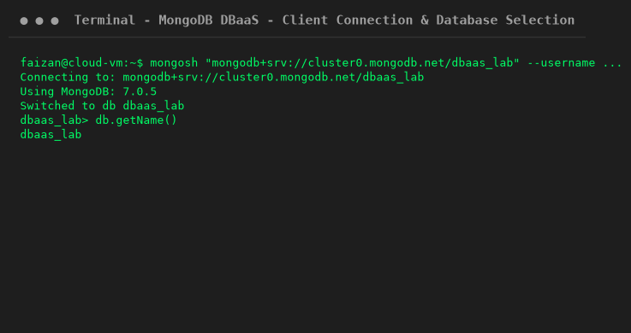
Step 2: Insert Documents (Create Operation)
Insert sample student documents into the students collection:
Command: db.students.insertMany([{ student_id: 1, name: "Aarav Shah", department: "Computer", semester: 5 }, { student_id: 2, name: "Priya Sharma", department: "IT", semester: 5 }])
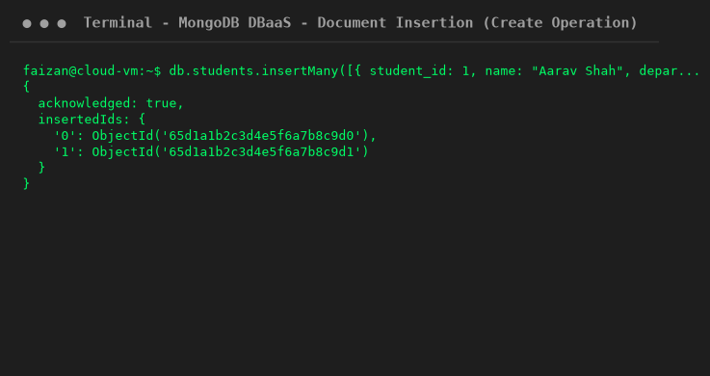
Step 3: Query Documents (Read Operation)
Query and inspect inserted documents from the collection:
Command: db.students.find().pretty()
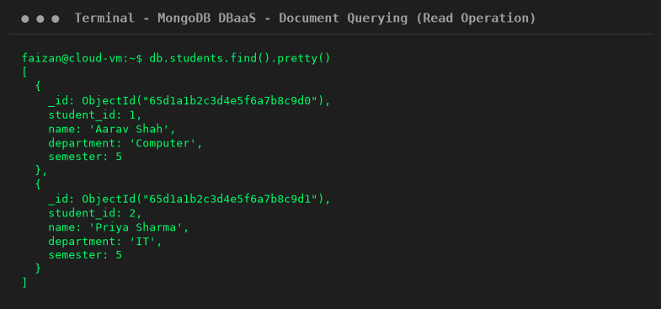
Step 4: Update & Delete Documents (Update & Delete Operations)
Update a record and delete a specified document from the collection:
Command: db.students.updateOne({ student_id: 1 }, { $set: { semester: 6 } }) && db.students.deleteOne({ student_id: 2 })
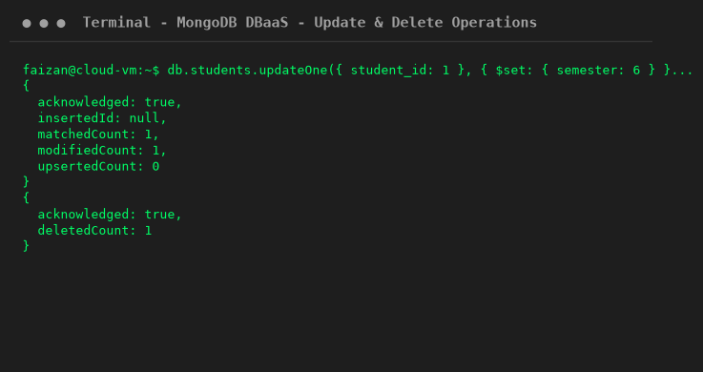
5. Viva Questions & Answers
Q1: What is DBaaS?
Ans: DBaaS is a managed cloud service that provides database functionality without requiring underlying server administration.
Q2: What is the main difference between SQL and NoSQL?
Ans: SQL databases use structured tables and schemas, whereas NoSQL databases store dynamic documents, key-value pairs, or graphs.
Q3: What does CRUD stand for?
Ans: CRUD stands for Create, Read, Update, and Delete—the four basic operations of persistent storage.
Q4: What is MongoDB Atlas?
Ans: MongoDB Atlas is a fully managed cloud Database as a Service provided by MongoDB.
Q5: Why is network security crucial for cloud databases?
Ans: To restrict database access exclusively to authorized IP addresses and application services, preventing data breaches.
6. Conclusion
In this experiment, the Database as a Service (DBaaS) cloud service model was studied and demonstrated using MongoDB. CRUD operations were successfully executed via the MongoDB shell (`mongosh`) and recorded with screenshots, illustrating how DBaaS simplifies database provisioning, maintenance, and scalability.

